**Assignment 1**

// Abstract base class

abstract class Shape2 {

    // Abstract method to calculate area

    abstract void calculateArea();

}

// Circle2 class extends Shape2

class Circle2 extends Shape2 {

    double radius;

    // Constructor to initialize radius

    Circle2(double radius) {

        this.radius = radius;

    }

    // Override to calculate and display area of the circle

    @Override

    void calculateArea() {

        double area = Math.PI * radius * radius;

        System.out.println("Area of Circle: " + area);

    }

}

// Square2 class extends Shape2

class Square2 extends Shape2 {

    double length;

    // Constructor to initialize length

    Square2(double length) {

        this.length = length;

    }

    // Override to calculate and display area of the square

    @Override

    void calculateArea() {

        double area = length * length;

        System.out.println("Area of Square: " + area);

    }

}

// Main class

class Shape2Main {

    public static void main(String[] args) {

        Circle2 circle = new Circle2(5);

        Square2 square = new Square2(4);

        circle.calculateArea(); // Calculate and display area of the circle

        square.calculateArea(); // Calculate and display area of the square

    }

}

**OUTPUT:**

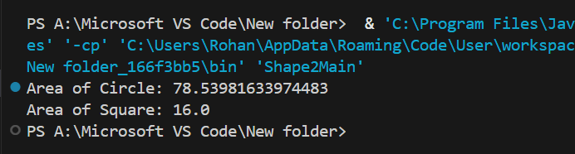

**Assignment 2**

import java.util.Scanner;

// Base class

public class Animal2 {

    // Method to make animal sound

    void makeSound() {

        System.out.println("The Animal makes sound");

    }

}

// Dog2 class inherits from Animal2 and overrides makeSound

class Dog2 extends Animal2 {

    @Override

    void makeSound() {

        System.out.println("The Dog barks");

    }

}

// Cat2 class inherits from Animal2 and overrides makeSound

class Cat2 extends Animal2 {

    @Override

    void makeSound() {

        System.out.println("The Cat meows");

    }

}

// Main class

class Animal2Main {

    public static void main(String[] args) {

        // Display menu to user

        System.out.println("Choose an Animal:");

        System.out.println("1. Dog");

        System.out.println("2. Cat");

        Scanner scanner = new Scanner(System.in);

        int choice = scanner.nextInt(); // Read user choice

        switch(choice) {

            case 1:

                Dog2 dog = new Dog2();

                dog.makeSound();

                break;

            case 2:

                Cat2 cat = new Cat2();

                cat.makeSound();

                break;

            default:

                Animal2 animal = new Animal2();

                animal.makeSound();

                break;

        }

        scanner.close(); // Close the scanner

    }

}

**OUTPUT:**

